**Lab 3 –Azure Resource Manager PowerShell**

**Description:**  The cmdlets in the **AzureRM** PowerShell modules let you use Resource Manager in Azure. These are from a central repository for PowerShell content called the PowerShell Gallery(www.PowerShellGallery.com). Installing items from the Gallery requires the latest version of the PowerShellGet module, which is available in Windows 10, in Windows Management Framework (WMF) 5.0, or in the MSI-based installer (for PowerShell 3 and 4). Windows 10 comes with WMF 5.0 by default.

In order to download the AzureRM, the process will prompt you to install a utility called NuGet (www.nuget.org). This is the package manager for the Microsoft development platforms.

I like to use the Windows PowerShell Integrated Scripting Environment (ISE) to create and run my scripts. It has a basic debugger so that you can debug your scripts. There are three sections in the ISE.

Script pane

Where you write, run and debug scripts

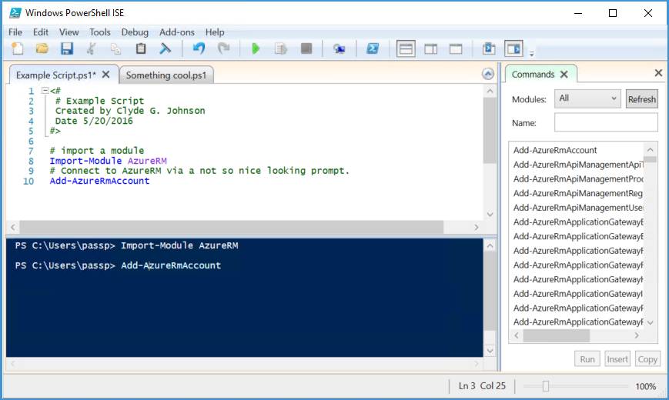

Command add-on pane

PowerShell ISE in v3 ships with an Add-on built in called Commands. This Add-on is a very useful learning and reference tool since it provides access to help info for cmdlets and will help you add the necessary parameters you are looking for

Console pane

Where you run individual commands and see the results of the scripts you run.

|  |  |
| --- | --- |
| Installing the AzureRM PowerShell Modules | |
| Setup links to PowerShell ISE | 1. Search for PowerShell. 2. Right Click on Windows PowerShell ISE and **pin to Start**. 3. Right Click on Windows PowerShell ISE and **pin to the taskbar**. |
| Launch PowerShell ISE as an Administrator | 1. Hold down the **Right shift key** on your keyboard and Right click on the ISE, choose **“Run as administrator”** from the menu that appears. 2. Click **Yes** at the UAC prompt that appears. |
| Install the Azure Resource Manager modules from the PowerShell Gallery | 1. In the PowerShell ISE in the console pane, type the following command   **Install-Module AzureRM**   1. When the “NuGet provider is required to continue” popup appears, Click on **Yes** 2. When the “Untrusted repository” popup comes up. Make SURE that PSGallery is mentioned in the message, then click on **Yes to All** button   **Restart your computer.** |
| Check for installed modules | 1. When you restart the ISE. You should see AzureRM commands in the command add-on pane. |

|  |  |
| --- | --- |
| Connecting to the Azure Portal | |
| Set Execution Policy | 1. In the PowerShell ISE console pane, type the following command.   **Set-ExecutionPolicy RemoteSigned**   1. When the Execution Policy Change popup appears. Click **Yes**.   **Note: This will enable scripts created remotely to run. If you download a script from the internet. You might have issues running it, unless you unblock it.** |
| Import AzureRM powershell cmdlets. | 1. In the PowerShell ISE console pane, type the following command.   **Import-Module AzureRM** |
| Connect to your Azure Account using Resource Manager portal. | 1. In the PowerShell ISE console pane, type the following command.   **Add-AzureRmAccount**  **This will prompt for your Azure username and password.** |
| Results: |  |